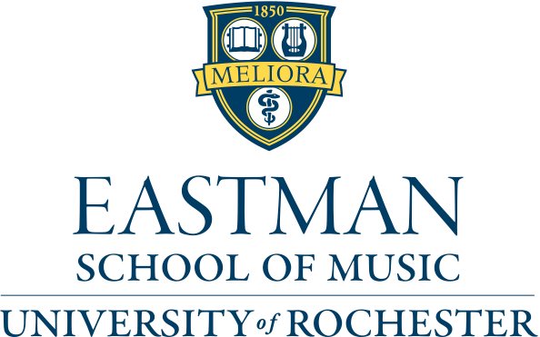

Department of Organ, Sacred Music, and Historical Keyboards
from the studio of Edoardo Bellotti
Käthe Wright Kaufman, organ

Program

Toccata and Fugue in D Minor (“Dorian”), BWV 538 J. S. Bach
(1685-1750)

Andante and Variations in D Major Felix Mendelssohn (1809-1847)

Master Tallis’s Testament Herbert Howells
(1892-1983)

from Esquisses Byzantines Henri Mulet
No. 3 Rosace (1878-1967)

Trivium (1988) Arvo Pärt
(b. 1935)

Symphony No. 3 in F# Minor, Op. 28 Louis Vierne I. Allegro maestoso (1870-1937)
II. Cantilène
V. Final

April 12, 2016, 7:00pm
Sacred Heart Cathedral, Rochester, N.Y.

This recital is presented in partial fulfillment of the requirements for the Bachelor of Music degree and as a confirming recital for the Performer’s Certificate.

My heartfelt thanks go to Professor Bellotti, for all his guidance and help.
Program Notes
J. S. Bach likely composed the Toccata in D minor during his time living in Weimar, from 1708-1717. In this concerto-like fantasia, Bach combines typical North German figurations with the Italian concerto’s ritornello form (as seen in the music of Vivaldi and Corelli). He also creates a sense of dialogue in an instrumental idiom through his use of the motives. At several points throughout the piece, one can perhaps imagine two dueling violins, and this is emphasized by Bach’s own instructions to the performer to change manuals throughout the piece. This Toccata is often referred to as the “Dorian” Toccata, which refers to its musical mode (a system of organizing pitches dating from the times of medieval chant).

Bach’s Fugue in D minor is one of his longest, at a length 222 measures. An alla breve fugue, it has a syncopated subject, which is almost vocal in nature. Throughout the composition, Bach writes with extremely rich counterpoint, complete with many harmonic crunches and suspensions. The subject enters over twenty times, sometimes in canon with itself at varying intervals. Towards the end as the piece nears its climax, Bach calls for a trill in the pedals. All of this intense counterpoint lends itself to a truly profound work.

Composed in July, 1844, Felix Mendelssohn's Andante & Variations in D Major is organized in the form of a theme and four variations that crescendo to a climax before the theme is stated once more with a sense of finality. Mendelssohn’s theme is a sweet, songlike melody that could easily be compared to a piece of German lied. In this ‘song without words,’ Mendelssohn uses devices such as third species counterpoint, triplets, scalar pedal passages and chromatic manipulation of the melody. Although written for organ, the piece demonstrates Mendelssohn’s fluency in the language of pianistic romanticism.

The British composer Herbert Howells was part of what some have called the “Second English Renaissance.” Along with his contemporaries, Ralph Vaughan Williams and Gustav Holst, he looked to the past for inspiration in his music. In fact, it was after hearing a performance of Vaughan Williams’ “Fantasia on a Theme by Thomas Tallis” that Howells was inspired to write his own homage to Tallis, “Master Tallis’s Testament,” in 1940. This piece is in the form of a theme and two variations, and it synthesizes the tonality and style of the 16th century with Howells’ own unique harmonic language. The theme is Howells’ own creation, and he transforms it dramatically throughout the variations. What begins as a quiet, pastoral tune grows to a roaring, majestic proclamation. The piece finishes with a quiet coda, returning to the opening mood. Howells himself considered “Master Tallis” one of his most “significant” works.

The Esquisses Byzantines (“Byzantine Sketches) were composed by Henri Mulet between 1914-1919. Each individual piece of the ten sketches was inspired by or dedicated to a specific part of the Sacré-Coeur Basilica in Paris, or to a liturgical function for which the church is used.
The pieces are as follows: Nef, Vitrail, Rosace, Chapell des morts, Campanile, Procession, Chant funèbre, Noël, In paradisum, and Tu es petra. The third sketch, “Rosace,” is inspired by the rose window in Sacré-Coeur.

Arvo Pärt wrote his three-movement piece, “Trivium” in 1980. The word ‘trivium’ originally meant a place where three roads met, but in Pärt's piece it is one of many instances of three: three voices interact in a tripartite structure. The work uses Pärt’s own minimalist style of tintinnabuli, in which he combines a melodic voice (the M-voice) with a bell-like voice outlining a triad (the T-voice). This tintinnabular structure is highly mystical for Pärt; the M-voice represents sin, mortality, and earth, while the T-voice represents godliness and redemption, and thus the combination of these two voices relates the cohabitation of the eternal with the mortal, and good with evil. There is a balance of divine order with earthly disturbances, which is especially seen in the relation of consonances and dissonances in the middle movement. In the final movement, the melody in the left hand (which is present in the other two movements, though not as obviously) is chant-like in nature. One cannot help but think that the holy Trinity (and the combination of all three parts to make one, that is, God) is also being represented in this piece.

Louis Vierne’s Symphony No. 3 in F# Minor is one of his greatest works for organ. Dedicated to his friend Marcel Dupré, Vierne composed this work in 1911, during a difficult period in his life. Not only did his mother die during the spring of this year, but so did Vierne’s mentor, Alexandre Guilmant. In addition, Vierne was passed over for the prestigious teaching position at the Paris Conservatoire. Finally, the Seine River flooded that year, which likely caused issues for Vierne at his position at Notre Dame Cathedral (located right on the river).

The first movement is brutally aggressive and chromatic to start, as Vierne provides momentum for the whole symphony with an energetic, sweeping motive. Following an extremely chromatic transition, Vierne introduces a calmer second theme. Throughout the movement Vierne weaves these two themes together, ending with a rush of jagged, descending chords on top of the first theme, heard in the pedals.

The Cantilène follows and brings calm to the stormy atmosphere left by the Allegro Maestoso. This song without words mournfully wanders around the tonality of A minor, with a few moments of sunshine. The coda is played on the organ’s célèste stop, as Vierne explores how quietly the organ can play.

The Final of Symphony No. 3 is one of the great French toccata masterworks, combining rapid ostinatos in the hands with a slow theme in the pedals. Back in F# minor again, Vierne juxtaposes the first rhythmic theme with a second lyrical theme, and the movement builds to a triumphant final statement of the theme in the bright key of F# major.

