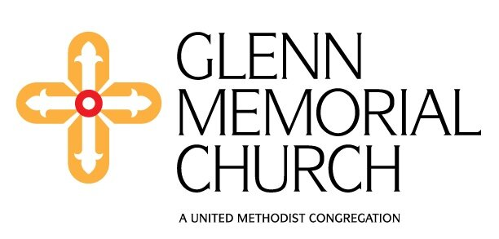
Käthe Wright Kaufman, organ
Associate Director of Music and Worship Arts
Sunday, March 17, 2024 at 2pm

Star Fantasy (2021) Kristina Arakelyan
(b. 1994)

Lullaby from Suite No. 2 (1976) Calvin Hampton
(1938-1984)

Symphony No. 3 in F# minor, Op. 28 (1911) Louis Vierne
i. Allegro maestoso (1870-1937)
ii. Cantilène
iii. Intermezzo
iv. Adagio
v. Final

You are invited to make a free-will donation to benefit the Glenn Music Fund, using the collection plate in the back of the Sanctuary. Thank you for your support!
Program Notes
Armenian-British composer Kristina Arakelyan trained at the Royal Academy of Music and University of Oxford, followed by a PhD in composition at King's College London. She has won numerous awards and accolades, from first prize in the BBC Proms Young Composers Competition in 2010, to representing the UK in the 2022 International Rostrum of Composers in Palermo, Italy. She has collaborated with the BBC Singers, the BBC Concert Orchestra, and the Choir of Pembroke College, Cambridge. Four of her compositions were featured in two BBC Proms performances this past summer. Star Fantasy is based on the Gregorian chant (pictured below), Alleluia: Vidimus stellam. After a tranquil opening, the music builds momentum as more stops of the organ are engaged and the rhythmic activity increases. By the end of the piece the Epiphany chant is heard a final time in the pedals, underneath the blazing glory of full organ.
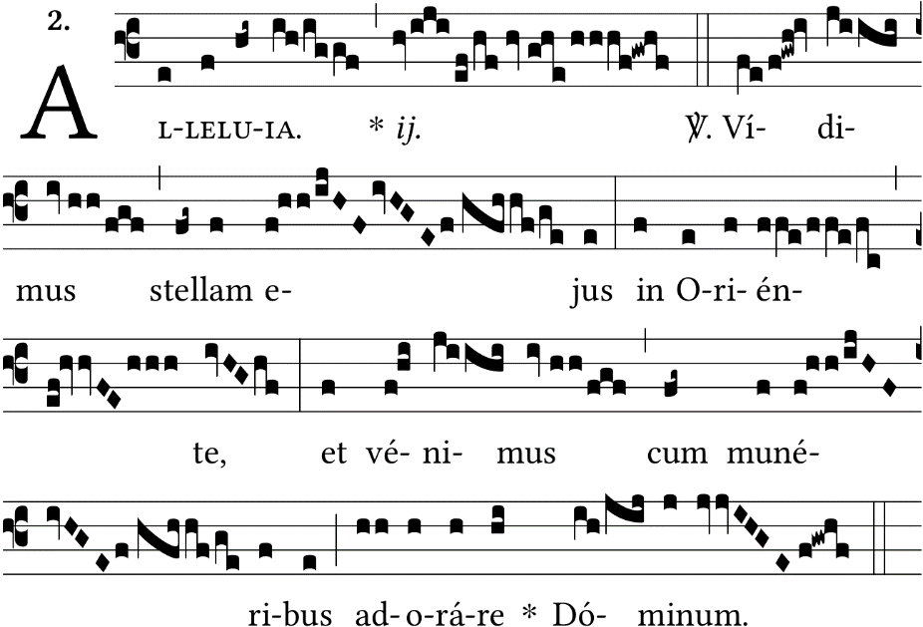
American composer and organist Calvin Hampton wrote a significant amount of music in his short life, for organ, orchestra, and choir. His anthems and hymns are often heard in churches today. Hampton is often remembered for his popular “Fridays at Midnight” Concert series at Calvary Episcopal Church in New York City, where he was Organist/Choirmaster from 1963-84. Lullaby was originally conceived as a rock piece, for which Hampton also wrote a text, “Lullaby for the End of Time.” The original tune was also used as the basis for rousing improvisations at Hampton’s organ recitals. Eventually, Hampton produced a set of variations on the tune, having transformed the rock anthem into this gentle, meditative organ piece. In its published form, the piece reflects Hampton’s introverted side, utilizing straightforward harmonies and varied textures to create a true gem. Opening with a chorale-like texture (featuring Hampton’s theme in the tenor range), the undulating registration conjures an atmosphere of tranquility. In each variation, the melody is accompanied by increasing rhythmic motion, before the work effortlessly reaches a dreamlike conclusion with a final flourish on the 4' Flute.
Louis Vierne composed his Symphony No. 3 in F# minor amidst much turmoil in his personal life in 1911. His marriage had broken up two years prior, and his mother died that March, in the same week as his mentor, Alexandre Guilmant. In addition, Vierne had recently been passed over for the prestigious role of Professor of Organ at the Paris Conservatoire (Eugène Gigout was chosen, instead). Vierne wrote the symphony while vacationing at his student Marcel Dupré's summer house, near Dieppe on the English Channel. The Symphony is dedicated to Dupré.
The first movement, Allegro maestoso, is brutally aggressive and chromatic to start, as Vierne provides momentum for the whole symphony with an energetic, sweeping motive. Following an extremely chromatic transition, Vierne introduces a calmer second theme. Throughout the movement Vierne weaves these two themes together, ending with a rush of jagged, descending chords on top of the first theme, heard in the pedals. The Cantilène follows and brings calm to the stormy atmosphere left by the opening movement. Heard in the voice of the Oboe stop and later the Trumpet, the tune wanders mournfully around the tonality of A minor, with a few moments of sunshine. The coda is played on the organ’s undulating voix célèstes, as Vierne explores how quietly the organ can play. The Intermezzo presents harmonies mainly derived from the whole-tone scale. Scholar Rollin Smith writes “This fascinating, sinister, elfish little movement has clutching handfuls of chromatics and little snatching rhythms that fall into place as impeccably as steps in a fine ballet.” Vierne describes the Adagio as a “song without words,” and you will hear many painfully beautiful chords that possibly betray Vierne's disquietness during this time. The movement’s post-Wagnerian harmonies and frequent appoggiaturas create a truly beautiful, if not pained, mood. The Finale is a thrilling, spooky toccata. It is in classical sonata form, wherein the first subject is introduced in the pedals, a more relaxed second subject is heard in the relative key of A Major, and at the conclusion the two themes are heard in conjunction. While this music is challenging for the hands, as would be expected in any toccata (the name of which derives from the Italian toccare, "to touch"), Vierne also challenges the organist's feet, especially on the final page, when they must perform almost a demented version of the arpeggiated Alberti bass pattern on the pedals.

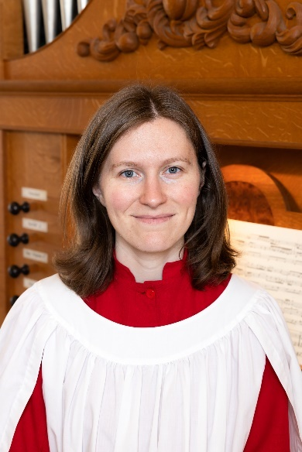
Käthe Wright Kaufman works as the Associate Director of Music and Worship Arts at Glenn Memorial United Methodist Church in Atlanta, where she serves as principal keyboardist and accompanist for services, oversees maintenance of the 1982 Casavant Frères organ, and aids the Director of Music and Worship Arts in shaping and supporting a vibrant worship and music program. She also serves the Candler School of Theology at Emory University as Chapel Organist. Previously, she worked as Organ Scholar in the UK (Peterborough and Truro) and Western NY (Rochester and Buffalo). A native of Chicago, Käthe was launched into church music early as a chorister at St. Luke’s Episcopal Church, Evanston. She was inspired to begin her organ studies a few years later with James Brown at the Music Institute of Chicago. For both undergraduate and graduate study, she attended the Eastman School of Music in Rochester, NY, where she studied organ, harpsichord, and improvisation with William Porter and Edoardo Bellotti, and organ with David Higgs for her Master’s degree. Käthe has performed for the radio program Pipedreams Live!, and she has performed in venues such as St. Thomas Church, NYC; Grace Cathedral, San Francisco; The Cathedral of St. Philip, Atlanta; Christ Church Cathedral, Nashville; and Clare College Chapel, Cambridge; St. Edmundsbury Cathedral; Peterborough Cathedral; and Truro Cathedral, in the UK. She has received several awards, including Eastman’s Gerald Barnes Award for Excellence in Pipe Organ (2013), the inaugural VanDelinder Prizes in Liturgical Organ Skills at Christ Church, Rochester (2014 & 2015), and first place in the West Chester University International Organ Competition (2015). She was recently featured as a performer at the American Guild of Organists’ National Convention in Seattle, WA (2022) and at the Anglican Association of Musicians’ National Convention in Dallas, TX (2023). Upcoming engagements include concerts in Albuquerque, NM and England this summer. Käthe is an Associate of the American Guild of Organists and a published composer with Selah Publishing Company.

Don’t miss these upcoming musical events at Glenn!
- Holy Week at Glenn:
3/28 Maundy Thursday @ 7pm in the amphitheater with music from The Gathering band
3/29 Good Friday @ 6.30pm Organ prelude featuring music by Bach, Demessieux, Pärt, & Rimkus
@ 7pm Service of Tenebrae featuring music by Chilcott, Lotti, & Sanders
- 3/31 @ 11am Easter morning with Brass featuring music by Phillips, Vaughan Williams, & Widor
- 5/5 @ 11am Sunday Worship celebrating our Music Ministry with choral masterworks by Britten & Howells
- 5/5 @ 4pm Kinnara: Immortal Bach (tickets available at www.kinnara.org/performances)

Glenn Church Welcomes You
Glenn Memorial United Methodist Church is committed to loving God and loving neighbor with our whole selves - heart, mind, soul, and strength. As Jesus loved those around him, we believe that all persons are of sacred worth and dignity as part of God’s creation. We welcome all persons into the full life and ministry of our congregation, regardless of race, culture, ethnicity, age, sexual orientation, gender identity, family or socioeconomic status, education, politics, physical or mental ability, or faith history.

Worship with us in person or online - Sundays at 8:30 a.m., 11:00 a.m., & 5:00 p.m.
1660 North Decatur Road NE, Atlanta, GA 30307 on the Emory University Campus, 404-634-3936

