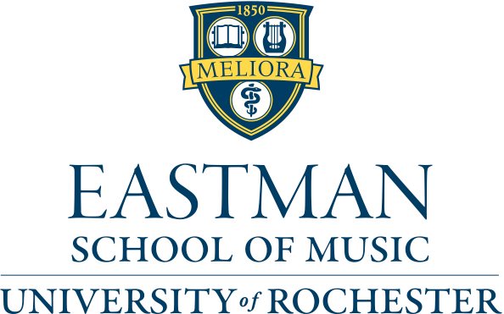

Department of Organ, Sacred Music, and Historical Keyboards
from the studio of David Higgs
Käthe Wright Kaufman, organ

Program

Prelude and Fugue in D Major, BWV 532 J. S. Bach
(1685-1750)

from Suite No. 2 Calvin Hampton
II. Lullaby (1938-1984)
from Four Extemporizations Percy Whitlock
III. Fidelis (1903-1946)

from Symphonie VI Charles-Marie Widor
I. Allegro (1844-1937)

April 25, 2018, 1:00pm
Schmitt Hall, Eastman School of Music, Rochester, NY

This recital is presented in partial fulfillment of the requirements for the Master of Music degree.

